Pictographs used in the interaction diagrams



Non-instantiated data type active entity.



Non-instantiated data type passive entity.



Instantiated data type active entity



Instantiated data type passive entity.

Interaction Diagram

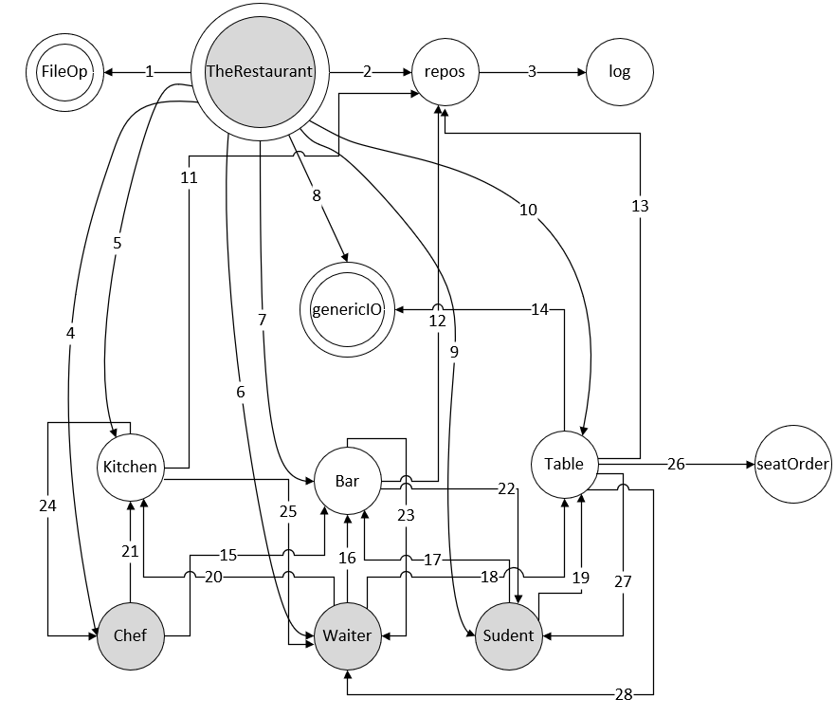

**1** - exists

**2** - instantiate

**3** - instantiate, openForWriting, writelnString, close, openForAppending

**4** - instantiate, start, join

**5** - instantiate

**6** - instantiate, start, join

**7** - instantiate

**8** - writelnString, writeString, redelnChar

**9** - instantiate, start, join

**10** - instantiate

**11** - setWaiterState, setChefState

**12** - setWaiterState, setStudentState

**13** - setWaiterState, setStudentState, setPortionsDelivered, setCoursesDelivered

**14** - writelnString

**15** - alertWaiter

**16** - lookAround, returnToTheBarAfterSalute, returnToTheBarAfterTakingTheOrder, returnToTheBarAfterPortionsDelivered, returnToTheBar, prepareBill, receivedPayment, sayGoodbye

**17** - enter, callTheWaiter, signalWaiter, shouldHaveArrivedEarlier, goHome

**18** - saluteTheClient, getThePad, deliverPortion, presentBill, haveAllPortionsBeenServed

**19** - takeASeat, firstToEnter, informCompanios, organizeOrder, describeOrder, chat, enjoyMeal, lastToEat, waitForEveryoneToFinish, lastToEnterRestaurant, honorTheBill, chatAgain

**20** - handTheNoteToTheChef, collectPortion

**21** - watchTheNews, startPreparations, continuePreparation, proceedToPresentation, deliverPortion, allPortionsDelived, haveNextPortionReady, alertWaiter, deliverPortion, orderBeenCompleted, cleanUp

**22** - setStudentState

**23** - setWaiterState

**24** - setChefState

**25** - setWaiterState

**26** - instantiate, write, getLast

**27** - setStudentState

**28** – setWaiterState